**Digital Logic Design Project Report**

**Digital Clock**

25-May-2020



**Members:**

**Vinay Kumar (19K-1320)**

**Darpan Kumar (19K-1309)**

**Muhammad Zeeshan (19K-1274)**

**Saneh Dhingana (18K-0175)**

**Introduction:**

A digital clock is a type of clock that displays the time digitally (i.e. in numerals or other symbols), as opposed to an analogue clock, where the time is indicated by the positions of rotating hands.

Digital clocks are often associated with electronic drives, but the "digital" description refers only to the display, not to the drive mechanism. (Both analogue and digital clocks can be driven either mechanically or electronically, but "clockwork" mechanisms with digital displays are rare).

**Idea of the Project:**

Our whole life is dependent on time. Each and everything, we do first we see time then we design our work according to time So, we thought that how the clock work and what is working behind it, and we also took help from 10-20 project list shared by you (Sir) then we select “**Digital Clock**” project to see the working behind it.

**Methodology:**

The 24-hour clock was designed using three pairs of Four-bit BCD counters (**74_90**) and Four-bit divide-by-twelve counters (**74_92**). The divide-by-twelve counters were used to provide the clock with the mod six operations. The circuit also made use of six BCD (**74_47**) and six seven segment displays, including one **OR** and two **AND** gates. Circuit below shows how a pair of (**74_90)** and (**74_92)** chips was used to design a divide-by-sixty counter.



**Working of (74_90) IC:**

**(74_90)**is basically a MOD-10-decade counter that generate a **BCD** output code. It consists of four *JK flip-flop*. To make BCD decade we connect **NAND** gate with Q1 & Q3 to reset at 10.

**Circuit Diagram:**



**Truth Table: IC 90:**



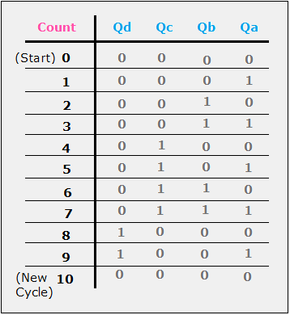

**Working of (74_92) IC:**

The (**74_92)** IC is a 4-Bit ripple counter *(4 cascaded counting elements)*. The individual counting circuits inside are partitioned into two blocks, one is a divide by two counter and the other capable of divide by 6, which when combined together effectively implements a divide by 12, perfect for the hour tracking register for a digital clock.

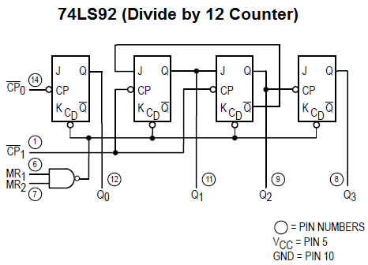

**Circuit Diagram:**

**Truth Table: IC 92:**



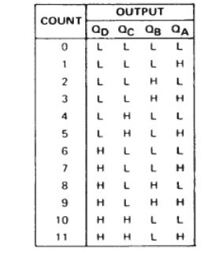

**Working of (74_47) IC & LED:**

 (**74_47**) IC Decodes binary to seven segment Display (BCD). Then connect with 7-segment LED which display in Decimal.

**Diagram:**

**Circuit Diagram:**



To Read Time

To Reset Time

**Simulation result:**



**Conclusion:**

The design of this clock was a lengthy and rewarding process. We used everything that we have learned throughout this class to put it together. In the end we have a working design of a clock that has been tested and successfully implemented.  
In general, this project has been successfully carried out and satisfies the overall aim and objectives of the project. In this project we learned time management and team work. We have also learned research methodology techniques.